AMERICAN HERDING BREEDS ASSN.
Junior Herding Dog
Herding TRIAL ARENA Dog

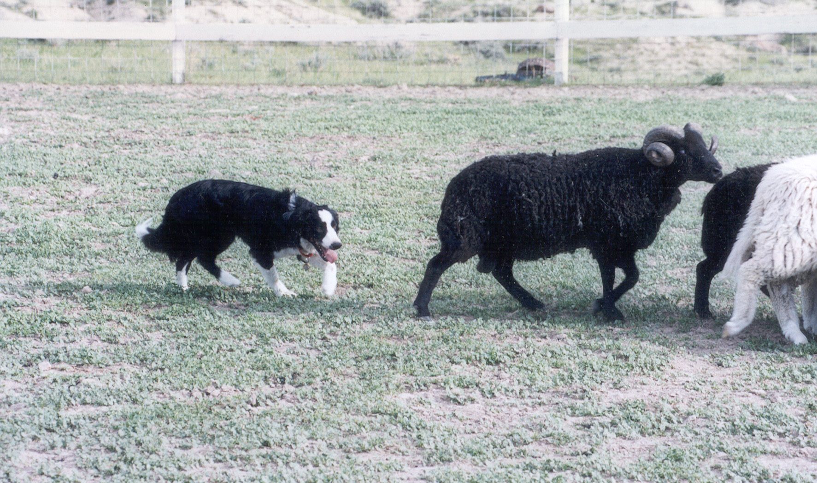

May 27, 2018

LOCATION:

Seaman Farm, Chisago, MN

Same location and stock as the AKC Trial in June
AHBA Course #4
Two Judges – Opportunity to earn a title.
S:
PRE-ENTRY (Due May 1, 2018) $25/run Day-Of (livestock available) $30/run

MAIL ENTRIES TO: Julia Torgerson – P.O.Box 693 – Forest Lake, MN 55025
jrtsplash@midco.com
Use the AHBA Recording Form as your entry form

AHBA HERDING TRIAL

JUNIOR HERDING DOG

Herding Trial Arena Dog

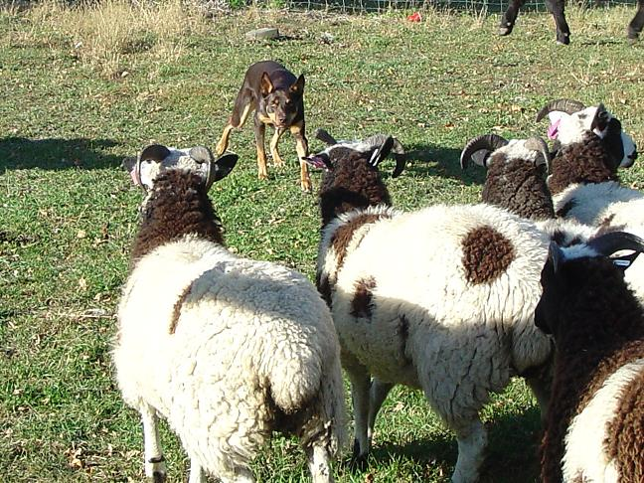

May 27, 2018

LOCATION:
Seaman Farm, Chisago, MN
Same location & Stock as GRSC June Trial

Two Judges – Two chances to earn an AHBA Title
PRE-ENTRY (Due May 1, 2018) $25/run Day-Of (livestock available) $30/run

MAIL ENTRIES TO: Julia Torgerson – P.O.Box 693 – Forest Lake, MN 55025
jrtsplash@midco.com
Use the AHBA Recording Form as your entry form

